**7-2 Project Two**

1. Create:
   1. interactive options to filter the Austin Animal Center Outcomes data set
   2. a data table which dynamically responds to the filtering options
   3. a geolocation chart with a second chart of your choice that dynamically responds to the filtering options

1. Include the Grazioso Salvare logo and a unique identifier

1. Create a data table on the dashboard which shows an unfiltered view of the Austin Animal Center Outcomes data set (Completed in Milestone Six)

1. Develop database queries that match the required filter functions

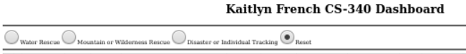

1. Modify or create the dashboard widgets that receive input from the interactive options and present those dynamic updates to the client (completed part of the data table in Milestone Six). Create charts that display data in response to updates

1. Take screenshots to include in your README file
   1. The starting state of your dashboard, which should include your widgets for the interactive options to filter data, the interactive data table, and the charts

* 1. Executions of your dashboard, showing the widgets after each of the following data filers has been applied (four screenshots total)
     1. Water Rescue

* + 1. Mountain or Wilderness Rescue

* + 1. Disaster or Individual Tracking

* + 1. Reset (returns all widgets to their original, unfiltered state)

